**R Code for Examples in the book**

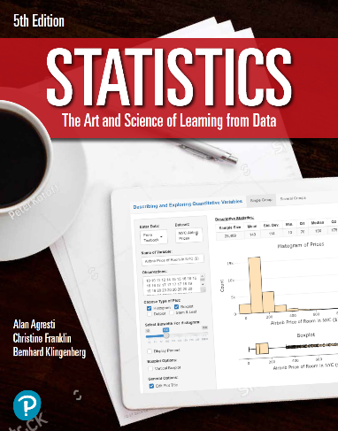

***“Statistics: The Art and Science of Learning from Data”***

**by Agresti, Franklin and Klingenberg, 5th edition**

**Chapter 13**

**Example 4: Female Athletes’ Weight – Estimating Residual Standard Deviation**

## Reading in data

athletes <- read.csv(file='https://raw.githubusercontent.com/artofstat/data/master/Chapter13/college_female_athletes.csv')  
colnames(athletes) #check column names

## [1] "TBW" "HGT" "X.BF" "BF" "LBM" "REPS55"   
## [7] "REPS70" "X1RM" "X1RM.TBW" "X1RM.LBM" "AGE"

## Fitting in multiple regression model

linReg <- lm(TBW ~ HGT + BF + AGE, data = athletes)  
linReg

##   
## Call:  
## lm(formula = TBW ~ HGT + BF + AGE, data = data)  
##   
## Coefficients:  
## (Intercept) HGT BF AGE   
## -97.6938 3.4285 136.4265 -0.9601

## To get the ANOVA table for the regression model

aov <- anova(linReg)  
aov # viewing ANOVA table

## Analysis of Variance Table  
##   
## Response: TBW  
## Df Sum Sq Mean Sq F value Pr(>F)   
## HGT 1 10281.1 10281.1 100.6140 1.904e-14 ***  
## BF 1 1902.7 1902.7 18.6203 6.054e-05 ***  
## AGE 1 224.1 224.1 2.1933 0.1438   
## Residuals 60 6131.0 102.2   
## ---  
## Signif. codes: 0 '***' 0.001 '**' 0.01 '*' 0.05 '.' 0.1 ' ' 1

rss <- aov$`Sum Sq`[4]  
dfError <- aov$Df[4]

## To estimate standard deviation

s <- sqrt(rss / dfError)  
s

## [1] 10.10861